What is Microsoft Endpoint Manager?
Microsoft Endpoint Manager (MEM) was a unified, integrated platform from Microsoft designed to help organizations manage and secure all their endpoints—such as desktops, laptops, mobile phones, and servers—from a single console.
However, it's important to note that Microsoft has since retired the "Microsoft Endpoint Manager" name and has now consolidated its endpoint management solutions under the brand name of Microsoft Intune. The Microsoft Intune admin center is the unified console for managing your endpoints.
While the name has changed, the core concept and the component services remain the same. Microsoft Endpoint Manager was never a single product with its own license; rather, it was the brand name that brought together several key Microsoft services into one unified platform.
Key Components of Microsoft Endpoint Manager (now part of Microsoft Intune)
The platform was built on the strengths of two major technologies:
- Microsoft Intune (Cloud-based): This is the cloud-native part of the solution. It focuses on Mobile Device Management (MDM) and Mobile Application Management (MAM). Intune is ideal for managing mobile devices (iOS, Android), macOS devices, and cloud-connected Windows PCs. It allows you to:
  - Enroll and configure devices.
  - Deploy, update, and protect mobile and desktop applications.
  - Enforce security policies (e.g., password requirements, disk encryption).
  - Manage data on both corporate-owned and "bring your own device" (BYOD) scenarios.
- Microsoft Configuration Manager (On-premises): Formerly known as System Center Configuration Manager (SCCM), this is the traditional, on-premises management solution. It's renowned for its deep, granular control over large fleets of Windows desktops and servers. Key capabilities of Configuration Manager include:
  - Operating System Deployment (OSD) and imaging.
  - Software distribution and patch management for on-premises clients.
  - Hardware and software inventory.
  - Centralized management of security settings and policies.
The Unified Approach
The main goal of the Microsoft Endpoint Manager branding was to show how these two powerful tools could work together seamlessly. This is achieved through a concept called co-management and tenant attach:
- Co-management: This is a key feature that allows you to simultaneously manage Windows 10/11 devices using both Configuration Manager and Microsoft Intune. You can choose which "workloads" (e.g., software updates, application deployment) are managed by which tool. This provides a bridge between your on-premises and cloud management strategies, allowing you to gradually shift to a more modern, cloud-centric model.
- Tenant Attach: This is a simpler integration where your Configuration Manager hierarchy is "attached" to your Intune tenant. It allows you to view your on-premises devices in the cloud-based Intune admin center and perform remote actions like restarting or syncing machine policy, all from a single pane of glass.
Other Components and Features
In addition to Intune and Configuration Manager, the Microsoft Endpoint Manager platform also included other integrated services that contribute to a comprehensive endpoint management strategy:
- Endpoint Analytics: Provides insights and scores on the performance of your devices, helping you to proactively identify and fix issues that impact user experience and productivity.
- Windows Autopilot: A technology that simplifies the deployment of new Windows devices. It enables a "zero-touch" or self-service experience where a device can be shipped directly to a user and automatically configured with the required apps and policies just by connecting to the internet.
- Endpoint Privilege Management (EPM): A newer feature that allows standard users to perform specific, IT-approved tasks that would normally require administrative privileges.
- Microsoft Defender for Endpoint: Integrates with the platform to provide advanced threat protection and security management across your devices.
In summary, while the name "Microsoft Endpoint Manager" is no longer actively used, the concept lives on under the Microsoft Intune brand. It represents Microsoft's vision for a modern, unified, and cloud-powered approach to endpoint management, bringing together the best of both on-premises and cloud technologies.
Understand Microsoft Intune
Microsoft Intune is a cloud-based endpoint management solution that is part of the broader Microsoft 365 ecosystem. It provides a unified and modern approach to managing and securing a wide range of devices, including desktops, laptops, mobile phones, and tablets, across various platforms like Windows, macOS, iOS, and Android.
Think of Intune as a central control center for your organization's devices and the applications and data on them. Its primary goal is to help organizations achieve a secure and productive workforce by managing devices and applications without requiring a traditional on-premises infrastructure.
Key Concepts of Microsoft Intune
- Cloud-based: Intune is a cloud-native service hosted on Microsoft Azure. This means it's accessible from anywhere with an internet connection and doesn't require you to maintain on-premises servers or infrastructure. This makes it highly scalable and flexible.
- Unified Endpoint Management (UEM): Intune is designed to manage all your endpoints—both corporate-owned and personally-owned (BYOD, or Bring Your Own Device)—from a single console. This eliminates the need for separate management tools for different device types.
- Integration with Microsoft Entra ID: Intune is deeply integrated with Microsoft Entra ID (formerly Azure Active Directory), which is Microsoft's cloud-based identity and access management service. This integration allows Intune to manage devices and apply policies based on user and group identities.
Core Features and Capabilities
- Mobile Device Management (MDM): This is the classic function of Intune. It allows you to enroll devices into management and apply policies to control a device's settings and features. For example, you can enforce password requirements, configure Wi-Fi and VPN profiles, or restrict access to the camera or app store.
  - Enrollment Methods: Intune offers various enrollment methods, including automatic enrollment for new devices (Windows Autopilot), user-driven enrollment for BYOD scenarios, and bulk enrollment for corporate-owned devices.
- Mobile Application Management (MAM): This is a powerful feature that allows you to manage and protect corporate data within applications without enrolling the entire device. This is particularly useful for BYOD scenarios, as it separates corporate data from personal data.
  - App Protection Policies: You can use MAM policies to enforce rules like requiring a PIN to open a work app, encrypting corporate data within the app, or preventing data from being saved to personal storage locations.
- Endpoint Security and Compliance: Intune helps you secure your endpoints and ensure they meet your organization's security standards.
  - Compliance Policies: You can define rules that devices must meet to be considered "compliant" (e.g., must have a minimum OS version, must be encrypted).
  - Conditional Access: When integrated with Microsoft Entra ID, you can use compliance policies to control access to corporate resources. For instance, you can create a policy that says, "Only compliant devices can access company email."
  - Security Baselines: Intune provides pre-configured security settings based on best practices from Microsoft security experts, which you can easily deploy to your devices.
- Application Deployment and Management: You can use Intune to deploy, update, and manage a wide variety of applications, including:
  - Microsoft 365 apps (e.g., Word, Excel, Teams)
  - Store apps (both public and private app stores)
  - Win32 and line-of-business (LOB) apps
  - Web links and shortcuts
- Integration with Configuration Manager (Co-management and Tenant Attach): While Intune is a modern solution, it's designed to work with existing on-premises infrastructure.
  - Co-management: This is a hybrid approach where you can manage Windows devices with both Configuration Manager and Intune at the same time. This allows you to gradually shift management workloads to the cloud at your own pace.
  - Tenant Attach: A simpler form of integration that allows you to see your on-premises Configuration Manager devices in the Intune admin center and run some remote actions on them.
- Windows Autopilot: Intune is the foundation for Windows Autopilot, a technology that simplifies the provisioning of new Windows devices. It enables a "zero-touch" deployment experience, where a device can be shipped directly from the vendor to an end-user and automatically configured with all the necessary apps, policies, and settings when they turn it on and connect to the internet.
Benefits of Using Microsoft Intune
- Centralized Management: Provides a single, unified console for managing a diverse fleet of devices and applications.
- Enhanced Security: Improves your organization's security posture with robust policies, conditional access, and threat protection.
- Flexibility and Agility: Supports modern work scenarios like remote work and BYOD, enabling a more flexible and productive workforce.
- Reduced Administrative Overhead: Automates many manual tasks, freeing up IT staff to focus on more strategic projects.
- Scalability: As a cloud service, it can easily scale to manage thousands of devices without requiring significant investment in hardware.
In essence, Microsoft Intune represents a shift from traditional, on-premises management to a modern, cloud-based approach that prioritizes identity, data, and security across all endpoints.

Understand Microsoft Endpoint Configuration Manager
Microsoft Endpoint Configuration Manager (MECM) is a powerful, on-premises systems management solution. It's the evolution of a product that has been a cornerstone of enterprise IT for decades, originally known as Systems Management Server (SMS) and then System Center Configuration Manager (SCCM). While its name has changed, its core purpose remains the same: to provide deep, granular control over large fleets of Windows desktops, laptops, and servers within a corporate network.
Core Capabilities and Features
Configuration Manager is a comprehensive platform that handles a wide range of administrative tasks, giving IT departments centralized control over the device lifecycle.
- Operating System Deployment (OSD): This is one of Configuration Manager's most well-known and powerful features. It allows for large-scale, automated deployment of Windows operating systems to new computers or existing ones. This includes "bare-metal" installations (no OS present), in-place upgrades, and the ability to capture and deploy custom images.
- Software Distribution and Application Management: Configuration Manager provides a robust and reliable way to deploy, update, and remove applications. It allows for targeted deployments to specific user or device collections, includes powerful detection methods to ensure applications are installed correctly, and provides a self-service portal called Software Center for end-users to install approved applications.
- Software Updates and Patch Management: It provides a highly controlled and customizable system for deploying software updates, including security patches. It integrates with Windows Server Update Services (WSUS) to download and distribute updates, allowing IT to create "update rings" and "maintenance windows" to precisely manage when and how patches are applied.
- Hardware and Software Inventory: Configuration Manager performs comprehensive scans of managed devices to collect detailed information about their hardware specifications, installed software, and other system data. This "asset intelligence" is invaluable for IT planning, troubleshooting, and ensuring software license compliance.
- Compliance Settings and Configuration Management: You can define and enforce a consistent security baseline across your organization's devices. This feature allows you to ensure that all managed computers adhere to specific policies, such as enforcing Windows Firewall settings, controlling registry keys, or ensuring the correct security configurations are in place.
- Remote Control and Remote Assistance: IT administrators can remotely access managed devices to provide assistance, troubleshoot issues, or perform maintenance tasks without physically being at the user's location.
- Reporting: Configuration Manager includes a powerful reporting feature, leveraging SQL Server Reporting Services (SSRS), that allows administrators to generate detailed reports on nearly every aspect of the managed environment, from software update compliance to hardware inventory.
Configuration Manager vs. Microsoft Intune
It's common to see Configuration Manager compared with Microsoft Intune. While they both manage endpoints, they are fundamentally different tools designed for different scenarios.
Feature | Microsoft Configuration Manager | Microsoft Intune
Primary Deployment Model | On-premises infrastructure (servers, databases, etc.) | Cloud-native service (SaaS)
Target Devices | Traditionally, on-premises, domain-joined Windows PCs and servers. | Cloud-connected devices (Windows, iOS, Android, macOS), especially for mobile and remote work.
Management Style | Agent-based, providing deep, granular control over the OS. | Profile-based, leveraging native OS APIs to enforce policies.
Key Strengths | Complex OS deployment, detailed inventory, server patching, large-scale software distribution over a LAN. | Mobile device and application management (MDM/MAM), managing remote and BYOD devices, security for cloud-based resources.
Ideal Use Case | Large enterprises with a significant number of on-premises Windows clients and servers in a traditional network. | Organizations with a modern, mobile workforce, a large number of BYOD devices, or those with a cloud-first strategy.
Export to Sheets
The Unified Approach: Co-management and Tenant Attach
Recognizing that many organizations have a mix of on-premises and remote devices, Microsoft has integrated Configuration Manager and Intune under the unified Microsoft Intune brand. This is not a merger of the products, but a strategic effort to allow them to work together.
- Co-management: This is a key hybrid approach that allows you to manage Windows 10/11 devices using both Configuration Manager and Intune simultaneously. You can choose which management "workloads" (e.g., software updates, application deployment, endpoint protection) are handled by which tool. This provides a flexible bridge, allowing you to gradually shift management functions to the cloud at your own pace while still leveraging your existing Configuration Manager infrastructure.
- Tenant Attach: This is a simpler form of integration that connects your on-premises Configuration Manager hierarchy to your Intune tenant in the cloud. It allows you to view your on-premises devices in the cloud-based Intune admin center and perform certain remote actions from a single, unified console, even if the devices are not enrolled in Intune.
In essence, Microsoft Configuration Manager remains a robust and essential tool for managing a traditional, on-premises Windows environment. However, its future is increasingly tied to its integration with the cloud-native capabilities of Microsoft Intune to provide a truly modern, comprehensive, and unified endpoint management solution.

Understanding MEM\Intune and Microsoft Configuration Manager\SCCM :-
Microsoft Configuration Manager (ConfigMgr) is an on-premises system(IT solutions and software installed and run on a company's own physical hardware, located within its own facilities or private data centers, rather than being hosted on external cloud servers) for managing Windows devices, while Microsoft Endpoint Manager (MEM) was the cloud-based suite that combined ConfigMgr with Microsoft Intune for unified, multi-platform management. The term "Microsoft Endpoint Manager" is now largely replaced by "Microsoft Intune," which serves as the product family for Microsoft's unified endpoint management platform. Therefore, the key difference is that ConfigMgr is on-premises, and MEM/Intune is the broader cloud-based service that integrates it for both cloud and hybrid management scenarios.
Microsoft Configuration Manager (ConfigMgr)
- Purpose: Primarily manages on-premises Windows devices and servers, handling software deployment, patch management, operating system deployment, and hardware/software inventory.
- Environment: An on-premises solution requiring its own infrastructure.
- Focus: Full, deep control over on-premises endpoints.
Microsoft Endpoint Manager (MEM) / Microsoft Intune
- Purpose:
A cloud-based platform that provides unified endpoint management and security.
- Components:
Combined Microsoft Intune and ConfigMgr into a single, unified solution.
- Environment:
Manages cloud-managed Windows 10 and other mobile devices (like iOS, Android, and macOS).
- Rebranding:
The Microsoft Endpoint Manager brand has been retired, and the platform is now known as the Microsoft Intune product family. The Microsoft Intune admin center is the place to manage devices.
Key Differences & Relationships
- Scope:
ConfigMgr is for on-premises, while MEM/Intune covers both cloud and hybrid environments, offering more comprehensive, modern management.
- Integration:
ConfigMgr can be "co-managed" or paired with Intune within the broader MEM suite to fill gaps and facilitate a move from on-premises to cloud management.
- Evolution:
MEM was the branding that brought together ConfigMgr and Intune, but Microsoft has since evolved to the "Microsoft Intune" product family, where Intune is the primary cloud management service.

Installing Microsoft Configuration Manager :-
Visit the following link to download it -
-------https://info.microsoft.com/ww-landing-microsoft-endpoint-configuration-manager.html?culture=en-us&country=us
Fill some details and click download-
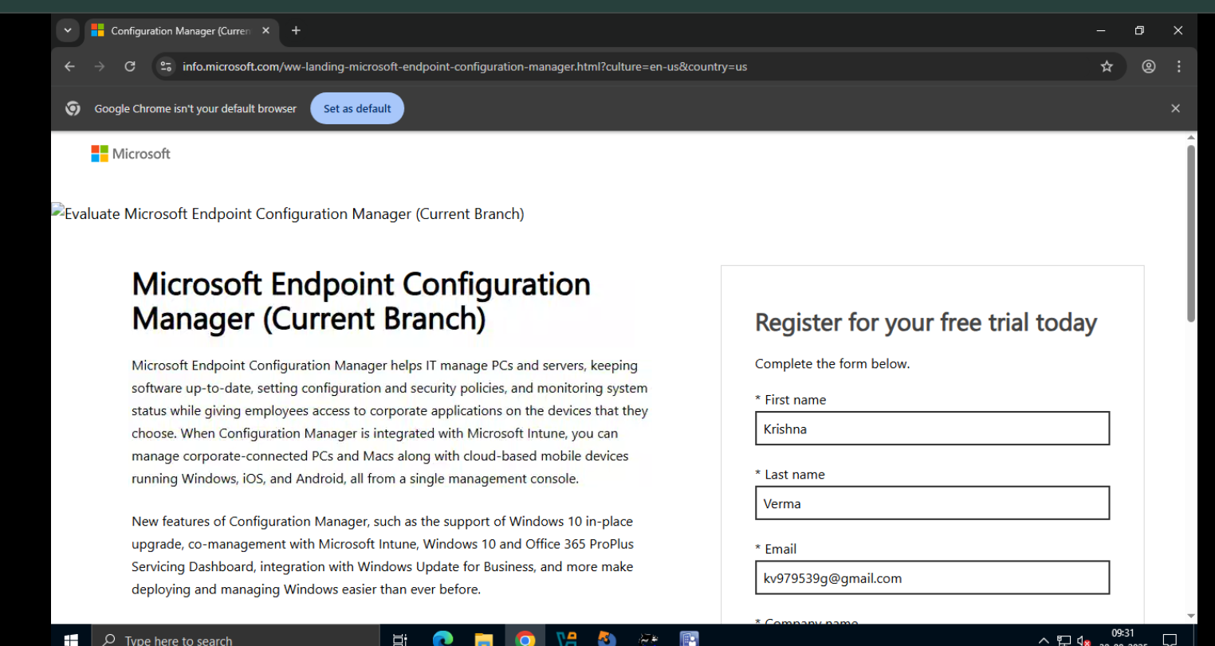
After Clicking download It started downloading-
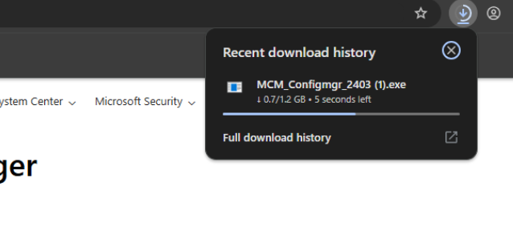

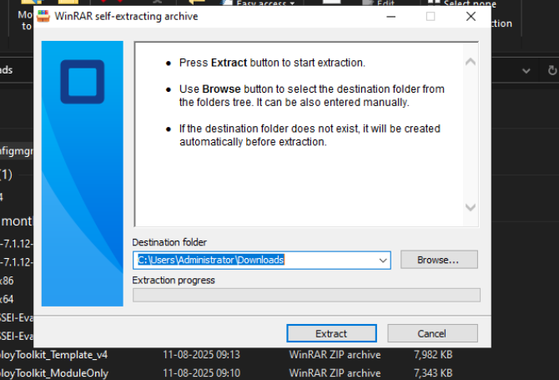
After Download click to extract folder the default path is-C:\Users\Administrator\Downloads.

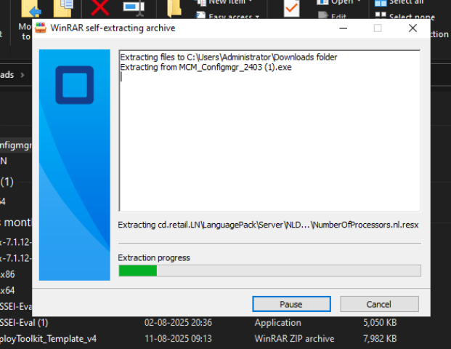

The default folder path is-C:\Users\Administrator\Downloads\cd.retail.LN
It open the cd.retail.LN

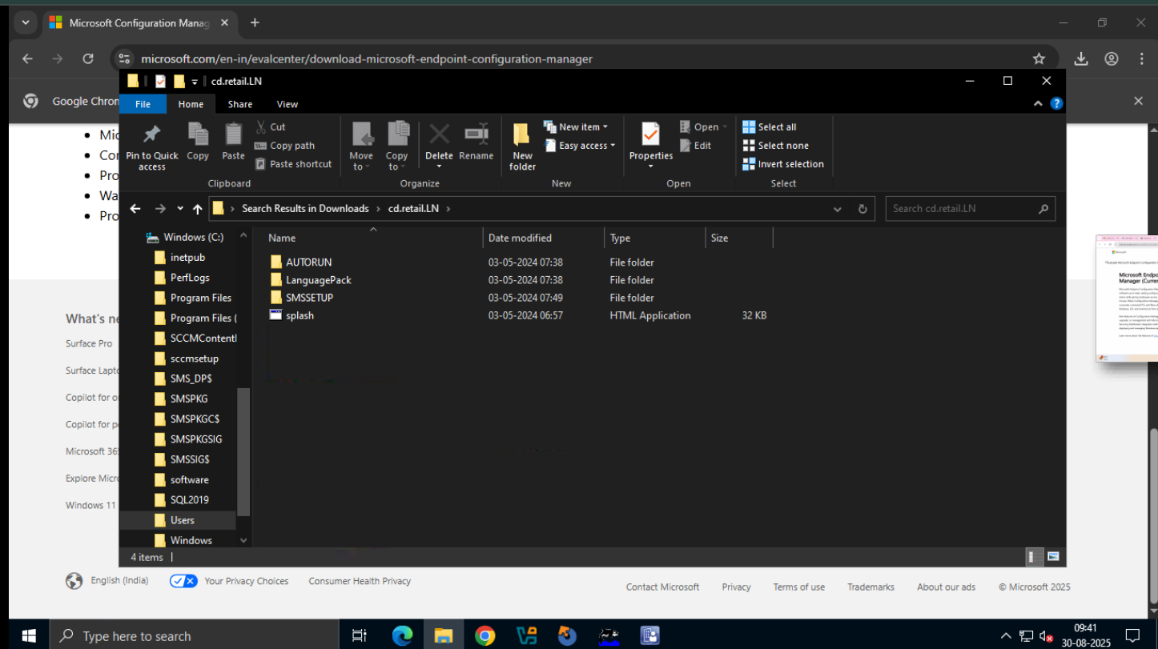
Click on splash then a popup window open for installation of MCM console.
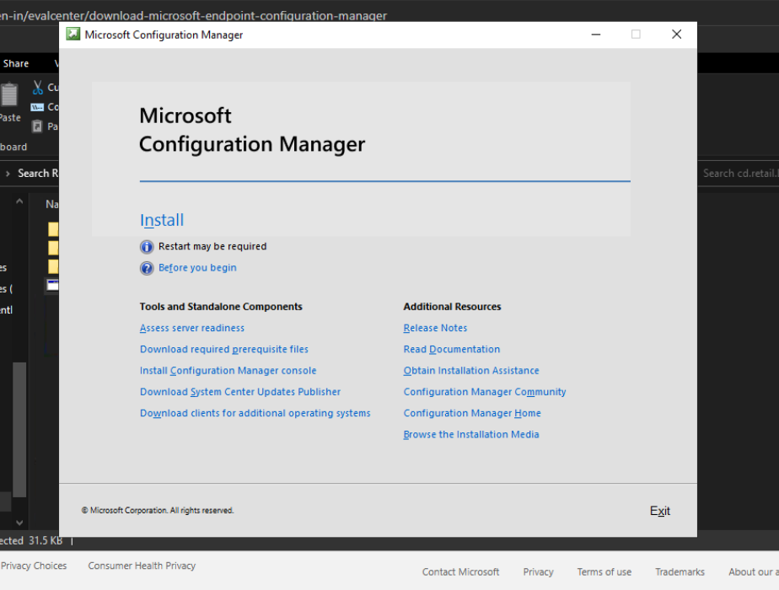

Installation Of Microsoft Deployment Toolkit –
Prerequisites
Before you install MDT, make sure these are in place:
- Windows Server / Windows 10/11 (latest updates installed).
- .NET Framework 4.5 or later (usually preinstalled).
- Windows ADK (Assessment and Deployment Kit) – download matching your OS version.
  - Install Deployment Tools
  - Install Windows Preinstallation Environment (Windows PE add-on)
- Administrative privileges on the system.

Steps to Install Microsoft Deployment Toolkit (MDT)
Step 1 – Download MDT
- Go to the official Microsoft site:
Microsoft Deployment Toolkit Download
- Download the latest version of MDT.
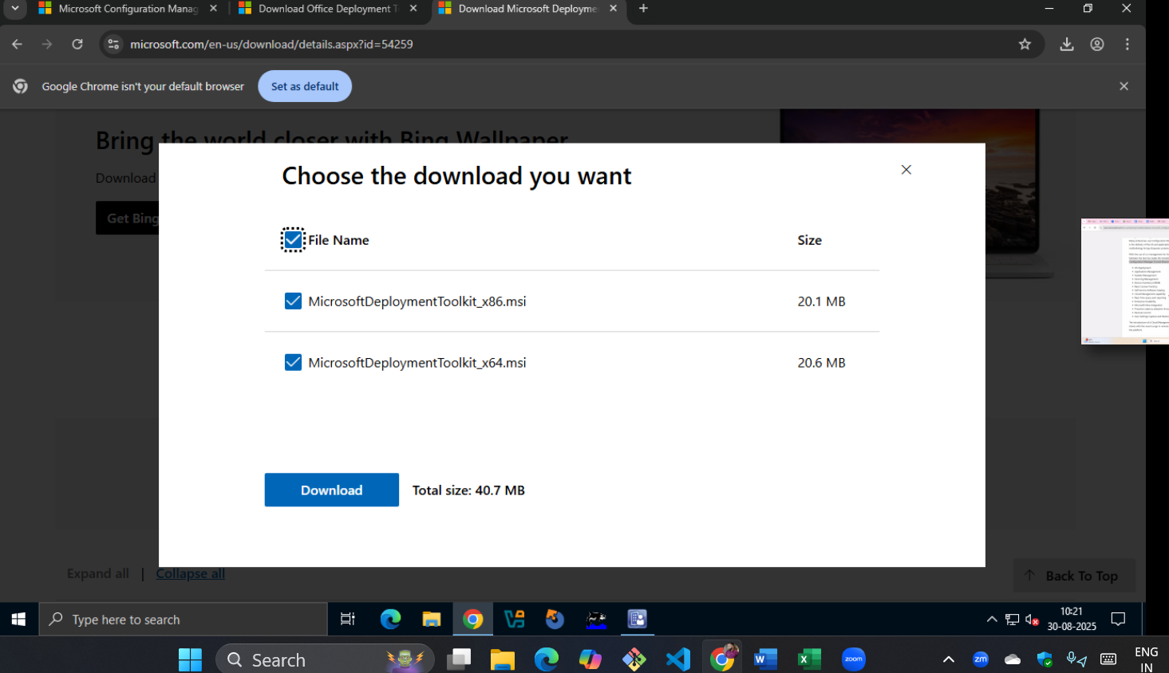
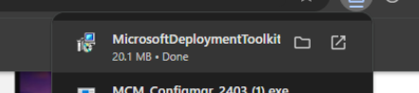
Step 2 – Install Windows ADK
- Run the ADK installer.
- Choose Deployment Tools feature → Install.
- Download and install the Windows PE add-on for ADK (separate installer).
- Restart the system if required.
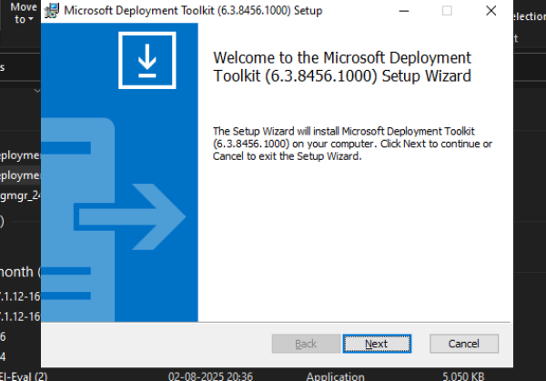
Step 3 – Install MDT
- Run the MDT installer (MicrosoftDeploymentToolkit_x64.msi).
- Accept the license terms.
- Choose the installation path (default is fine).
- Click Install → Wait for setup to finish.
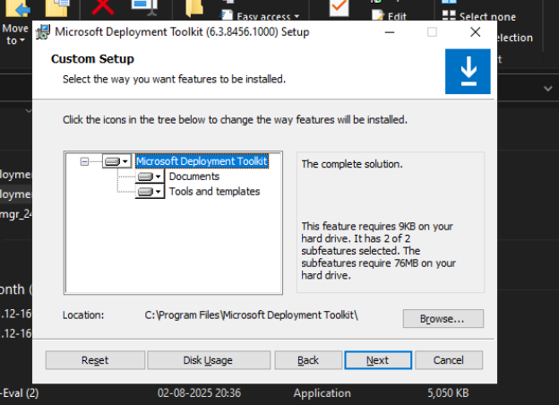
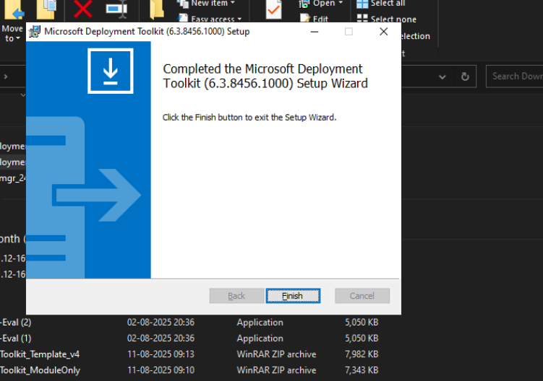

Step 4 – Verify Installation
- Go to Start Menu → Microsoft Deployment Toolkit.
- Open Deployment Workbench → It should load successfully.
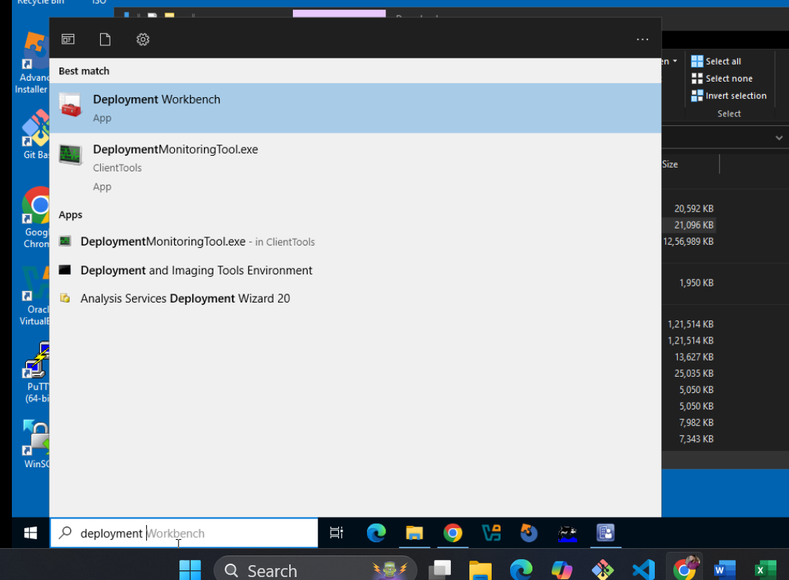
Step 5 – Configure MDT
- Open Deployment Workbench.
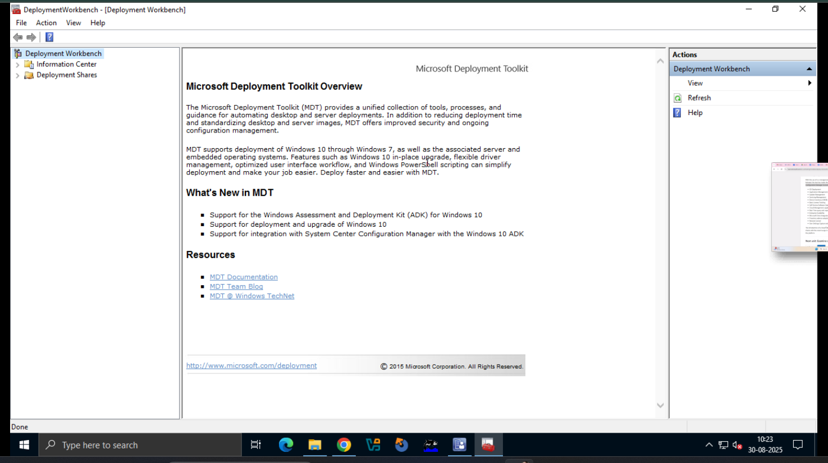
- Right-click Deployment Shares → New Deployment Share.
- Select a folder path (example: D:\DeploymentShare).
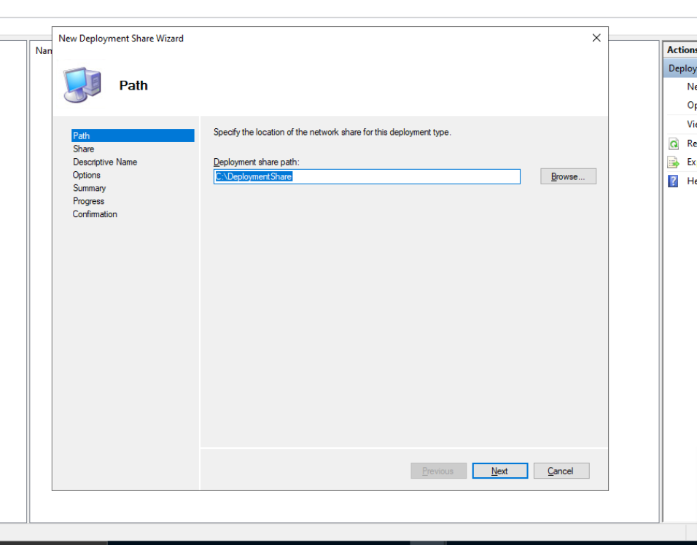
- Give a Share name (example: DeploymentShare$).
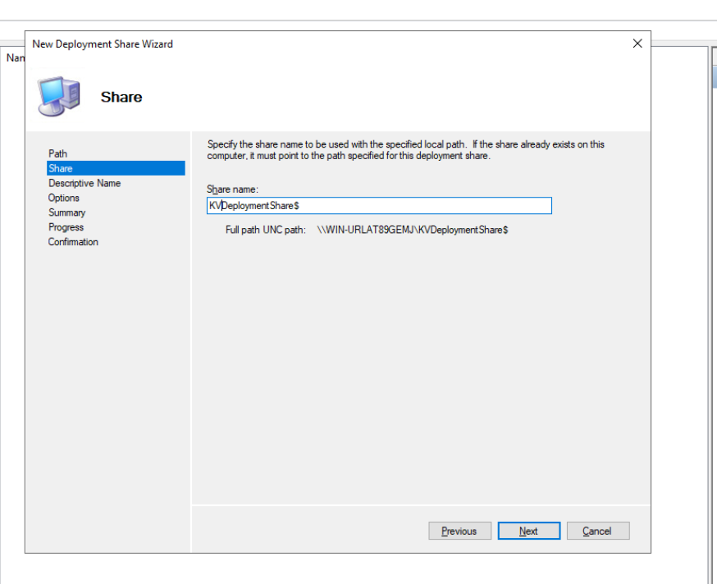
- Click Next → Finish.
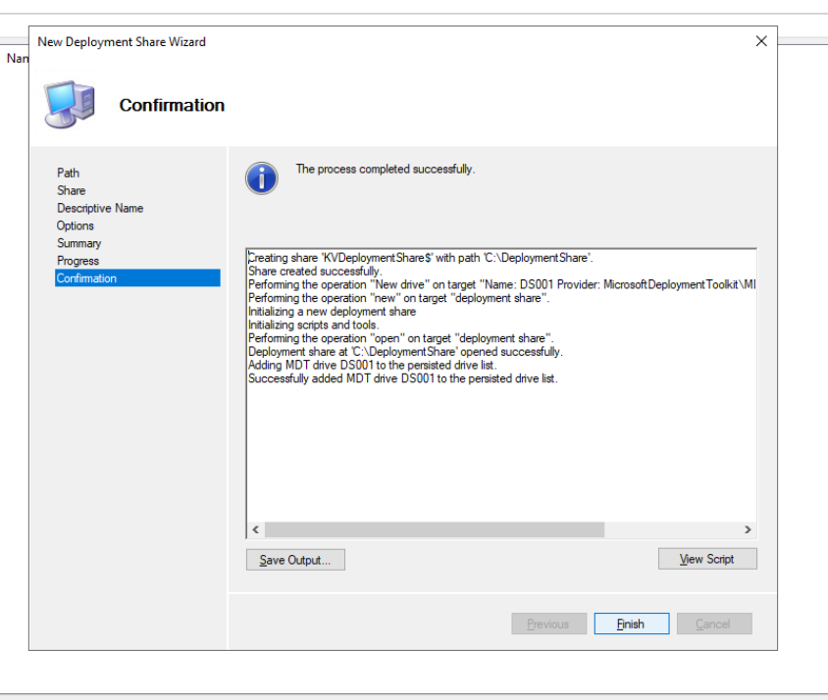
- Expand the new share to start adding:
  - Operating Systems (import Windows ISO).
  - Applications (Office, Chrome, etc.).
  - Task Sequences (to automate deployment).
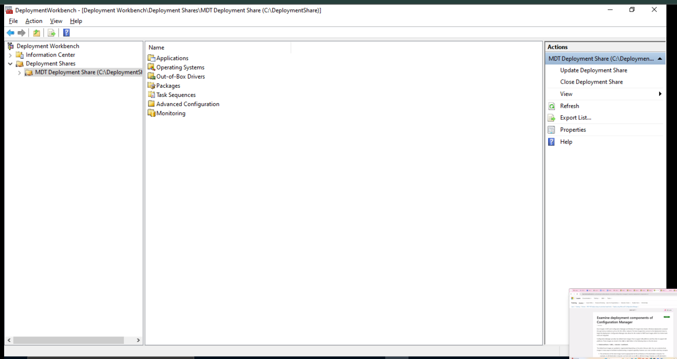
Now MDT is installed and ready to use.

Learn about Cloud Attach
"Cloud attach" is a modern, overarching term used by Microsoft to describe the process of connecting your on-premises Microsoft Configuration Manager (formerly SCCM) environment to the cloud, specifically to Microsoft Intune. It’s not a single feature but rather a family of integrated capabilities that provide a seamless bridge between your traditional on-premises management and the modern, cloud-based world.
The goal of Cloud Attach is to help organizations transition to modern management at their own pace, unlocking new cloud-powered features and insights without having to completely abandon their existing Configuration Manager infrastructure and processes.
Key Components of Cloud Attach
Cloud Attach is an umbrella term that primarily includes two key features:
- Tenant Attach: This is the foundational component of Cloud Attach and the first step in the journey.
  - What it does: Tenant Attach synchronizes device records from your Configuration Manager hierarchy to the Microsoft Intune admin center. The key here is that it does not enroll the devices in Intune. The devices remain primarily managed by Configuration Manager.
  - Benefits:
    - Single Pane of Glass: It provides a single, unified console (the Intune admin center) where you can see all your managed devices, both those managed by Intune and those managed by Configuration Manager.
    - Remote Actions: It allows you to perform real-time administrative tasks on your Configuration Manager-managed devices directly from the Intune admin center, such as:
      - Running PowerShell scripts.
      - Using CMPivot for real-time queries.
      - Viewing a device's timeline of events.
      - Installing applications.
    - Helpdesk Capabilities: IT support staff can use the Intune console to get information on on-premises devices and perform troubleshooting without needing access to the Configuration Manager console or the corporate network.
  - How it works: This is enabled by the Service Connection Point (SCP) role in your Configuration Manager hierarchy, which securely connects to the Microsoft cloud to upload the device data.
- Co-management: This is the next level of Cloud Attach and is a more powerful integration.
  - What it does: Co-management simultaneously manages Windows 10/11 devices with both Configuration Manager and Intune. The devices have both a Configuration Manager client and an Intune enrollment.
  - Benefits:
    - Best of Both Worlds: It allows you to leverage the strengths of both platforms. You can continue to use Configuration Manager for traditional tasks like complex OS deployment, software distribution over a LAN, and server management, while using Intune for cloud-native tasks like managing remote devices, enforcing security policies, and handling conditional access.
    - Gradual Migration: You can "flip a switch" for different management workloads (e.g., compliance policies, Windows Update policies, application deployment). For a given workload, you decide whether it is managed by Configuration Manager or Intune. This allows for a phased and controlled migration to the cloud.
    - Enhanced Security: It enables powerful security features, such as using Intune compliance policies and conditional access to protect corporate data.
Cloud Attach vs. Co-management
It's common for these terms to cause confusion, but the key is to see them in a hierarchical relationship:
- Cloud Attach is the umbrella concept. It's the overall process of connecting your on-premises ConfigMgr environment to the cloud.
- Tenant Attach is the first step in Cloud Attach. It provides basic visibility and remote actions without enrolling the device in Intune. It's the simplest way to gain immediate cloud value.
- Co-management is a specific feature that is part of the Cloud Attach family. It's a more advanced configuration that allows you to manage a device with both ConfigMgr and Intune simultaneously.
In a sense, every co-managed device is also a cloud-attached device, but a cloud-attached device (using only Tenant Attach) is not necessarily co-managed.
How to Configure Cloud Attach
The process is guided by a wizard in the Configuration Manager console, typically under the Administration > Cloud Services > Cloud Attach node.
- Azure Service Connection: The first step is to establish a connection between your Configuration Manager site and your Azure/Microsoft Entra ID tenant. This involves signing in with a Global Administrator account to register the necessary applications in your tenant.
- Choose Features: The wizard allows you to select which features you want to enable. You can choose a streamlined set of recommended defaults or manually select:
  - Tenant Attach: Upload all or a specific collection of devices.
  - Co-management: Start the process of enrolling devices into co-management and configure the workloads.
  - Endpoint Analytics: Enable data collection for user experience insights.
By using Cloud Attach, organizations can confidently begin their journey to modern management, improving efficiency, enhancing security, and better supporting a flexible and remote workforce, all while protecting their existing investment in Configuration Manager.
Understanding Desktop Analytics
This is a trick question! Microsoft retired Desktop Analytics in November 2022. It was a service for IT administrators to help them plan and prepare for Windows and Office upgrades. It's important to understand what it was, but also to know that it's no longer the go-to tool.
Simple Analogy: Imagine you're a home renovation contractor. Before you start knocking down walls and installing new floors (the upgrade), you need to figure out what's already there, what works, and what might break. Desktop Analytics was like a detailed blueprint and survey report for an entire office building, telling you things like: "This room's walls are weak, this wiring is old, and this window frame has a known issue."
Practical Example: Let's say a company wanted to upgrade all its computers from Windows 10 to Windows 11. They have thousands of devices and hundreds of different applications. They couldn't just do it blindly. Desktop Analytics would have:
- Inventoried everything: It would create a list of all devices and applications.
- Checked for compatibility issues: It would tell the IT team, "This specific version of accounting software on 50 laptops is not compatible with Windows 11 and will crash."
- Suggested a pilot group: It would recommend a small group of devices to test the upgrade on first, making sure the test group was diverse enough to represent the entire company's setup.
Tool Example: The tool itself was the Desktop Analytics service, which integrated with Microsoft Endpoint Configuration Manager (ConfigMgr). It was a cloud service that used data from millions of devices to provide its insights. Its capabilities have since been moved into the Microsoft Endpoint Manager admin center, which is a key part of the next topic.

2. Learn about Endpoint Analytics
This is the modern replacement for Desktop Analytics and goes much, much further.
Simple Analogy: If Desktop Analytics was just about preparing for a renovation, Endpoint Analytics is like a smart home monitoring system that constantly tells you how well everything is working. It's not just about one-time upgrades; it's about the ongoing, day-to-day user experience.
Practical Example: An employee calls the IT help desk complaining that their laptop is running slowly, and it takes forever to start up in the morning. Instead of blindly trying a bunch of things, the IT administrator can use Endpoint Analytics to get a "score" for that specific device. The tool might show:
- The device has a low "Startup performance score."
- The login time is consistently 2 minutes, which is slower than the company average.
- A specific application is crashing frequently, contributing to a low "Application reliability score."
- The device is missing a key security update, leading to a low "Work from anywhere" score.
The IT admin now has data-driven insights to solve the problem proactively, often before the user even calls.
Tool Example: Microsoft Endpoint Analytics is a feature within the Microsoft Endpoint Manager admin center. It collects data from devices managed by Microsoft Intune or ConfigMgr to provide:
- Performance Scores: Startup performance, application reliability, and a "Work from anywhere" score.
- Proactive Remediation: Automated scripts to fix common issues before users are impacted.
- Insights and Recommendations: Prioritized suggestions on how to improve the overall scores for all devices.

3. Understand Windows Autopilot
This is about the process of getting a new device ready for a user.
Simple Analogy: Think about a brand-new smartphone you buy. You take it out of the box, turn it on, and it walks you through a setup process: connecting to Wi-Fi, signing in with your account, and maybe downloading some apps. Windows Autopilot is like a corporate version of that process, but with a magic touch.
Practical Example: A company hires a new employee. Instead of the IT team having to physically take a new laptop, install the Windows image, join it to the corporate network, and manually install all the required apps (like Office 365, VPN, and antivirus), they can simply ship the laptop directly from the manufacturer to the new employee's home.
When the employee takes the laptop out of the box and turns it on, Windows Autopilot takes over:
- The laptop connects to the internet.
- It automatically recognizes that it belongs to the company.
- It prompts the employee to sign in with their corporate credentials.
- Once signed in, it automatically configures all the company settings, applies security policies, and downloads all the necessary business applications.
The employee is ready to work in minutes without any IT intervention.
Tool Example: Windows Autopilot is a set of technologies that work with Microsoft Intune and Microsoft Entra ID (formerly Azure Active Directory). The IT admin pre-registers the device's hardware ID in Intune. When the device connects to the internet, Intune recognizes the device and applies a pre-configured deployment profile, automating the entire setup.

Protect Your Endpoint Environment with Microsoft Endpoint Manager
Microsoft Endpoint Manager is a unified platform designed to help organizations manage and secure all their devices—from laptops and desktops to mobile phones—and the applications and data on them. It combines the power of Microsoft Intune (for cloud-based management) and Configuration Manager (for on-premises management) into a single console. This allows IT and security teams to maintain control and protect the company's digital assets in a world of remote work and diverse devices.
Let's explore the key aspects of this platform.
1. Learn About Managing and Protecting Devices
Managing and protecting devices is the foundation of a secure endpoint environment. This involves ensuring that every device accessing the corporate network is compliant with security policies, up-to-date, and free from threats.
- Device Enrollment: This is the process of getting a device under the management of Microsoft Endpoint Manager. This can be done automatically for new corporate devices using Windows Autopilot, or manually by employees on their personal devices (BYOD - Bring Your Own Device).
- Compliance Policies: These are rules that define what a "healthy" or "compliant" device looks like. Examples include:
  - Requiring a password or PIN for device access.
  - Mandating disk encryption (BitLocker).
  - Setting a minimum operating system version.
  - Ensuring the device is not "jailbroken" or "rooted."
  - If a device is non-compliant, it can be blocked from accessing company data, and the user can be notified to fix the issue.
- Endpoint Security Policies: These policies go beyond compliance to actively protect devices. This includes:
  - Antivirus and anti-malware management using tools like Microsoft Defender for Endpoint.
  - Firewall rules to control network traffic.
  - Vulnerability management to identify and remediate weaknesses.
Practical Example: An IT administrator can use Microsoft Endpoint Manager to create a policy that requires all company laptops to have BitLocker disk encryption enabled. If an employee's laptop isn't encrypted, the system can automatically block it from accessing the corporate network, email, and files, thereby preventing data theft if the laptop is lost or stolen.

2. Learn About Managing and Protecting Apps
Protecting devices isn't enough; you also need to manage the applications on those devices, as they are a common entry point for cyberattacks.
- Application Deployment: IT can use Endpoint Manager to automatically deploy, update, and remove applications on devices. This ensures all employees have the correct, approved software and that it's always up to date.
- App Protection Policies (APP): This is a critical feature for protecting corporate data on mobile devices, especially for BYOD scenarios. APP can apply security controls to the data within an application without managing the entire device.
- Application Control: This allows IT to specify which applications are allowed to run on a device. It can prevent users from installing and running unapproved or malicious software.
Practical Example: An employee is using their personal iPhone for work. They need to access their corporate email and files. The IT team can use App Protection Policies to:
- Require a PIN to open the Outlook app.
- Prevent the employee from copying and pasting corporate data from Outlook into a personal app like WhatsApp or a public cloud storage service.
- Automatically wipe only the corporate data from the apps if the employee leaves the company, without touching their personal photos, contacts, or messages.

3. Learn About Managing and Protecting Your Organization's Data
This is the ultimate goal of endpoint management. Protecting data involves a layered approach that ensures only authorized users and devices can access it, and that its movement is controlled.
- Conditional Access: This is a powerful feature that works with Microsoft Entra ID (formerly Azure Active Directory). It's the digital gatekeeper that enforces rules before access is granted. A Conditional Access policy might say: "A user can only access corporate data from a device that is both compliant with our security policies and is in a trusted location."
- Data Loss Prevention (DLP): While a broader concept, Endpoint Manager contributes to DLP by controlling how data can be used within managed applications. For instance, it can block a user from saving a corporate document to a personal cloud drive like Google Drive.
- Remote Actions: In the event of a lost or stolen device, IT can remotely perform actions like:
  - Remote Wipe: Erase all corporate data from the device.
  - Full Factory Reset: Erase all data and restore the device to its factory settings.
  - Remote Lock: Lock the device to prevent unauthorized access.
Practical Example: An employee loses their company-issued laptop. The IT team uses Microsoft Endpoint Manager to perform a remote wipe. The laptop is rendered useless to the thief, and no corporate data is compromised.

4. Understand the Endpoint Environment
An "endpoint environment" is simply the collection of all devices that connect to and interact with an organization's network and data. It includes:
- Traditional Devices: Laptops, desktops, and servers.
- Mobile Devices: Smartphones and tablets (corporate-owned and personal).
- Virtual Endpoints: Remote desktops and virtual machines.
- IoT (Internet of Things) Devices: In some cases, devices like smart printers, security cameras, or point-of-sale systems can also be considered endpoints.
The key challenge for IT is that this environment is no longer confined to a physical office. It's distributed and dynamic, which is precisely what tools like Microsoft Endpoint Manager are designed to handle.

5. Understand Platform Considerations
Microsoft Endpoint Manager is designed to be a "unified" platform, meaning it supports a variety of operating systems. However, different platforms have unique features and management capabilities. When planning a deployment, you need to consider:
- Windows: This is the most deeply integrated platform. Tools like Windows Autopilot, Windows Hello for Business, and direct management of Microsoft Defender for Endpoint are core to the platform.
- macOS: Endpoint Manager provides robust support for Apple devices, including deployment of apps, compliance policies, and security configurations.
- iOS/iPadOS and Android: These platforms are managed through Mobile Device Management (MDM) and Mobile Application Management (MAM). You need to decide whether to manage the entire device or just the corporate data on it. This is where App Protection Policies are crucial.
- Linux: While support is more recent, Microsoft Endpoint Manager is expanding its capabilities to include Linux devices, allowing for a more comprehensive security posture across all platforms.

Understand device management using Microsoft Endpoint Manager
Protecting an endpoint environment with Microsoft Endpoint Manager is a comprehensive process that covers the entire lifecycle of a device, from the moment it's provisioned until it's retired.
1. Understand Provisioning
Device provisioning is the process of setting up a new device for a user. Instead of IT teams manually configuring each machine, Microsoft Endpoint Manager automates this process.
- Windows Autopilot: This is a key provisioning technology. A new device can be shipped directly from the manufacturer to the user. When the user turns it on and connects to the internet, Windows Autopilot automatically registers the device with the organization, enrolls it in Endpoint Manager, and applies the necessary configurations and applications. This is a "zero-touch" process for the IT department, making it highly efficient.
2. Learn About Enrolling Devices
Enrollment is how a device is brought under the management of Microsoft Endpoint Manager. This is a critical step that allows the organization to enforce security policies and manage the device.
- Automatic Enrollment: For Windows devices, this can be configured so that when a user signs in with their corporate credentials, the device is automatically enrolled.
- Company Portal: For personal devices (Bring Your Own Device or BYOD), users can download the Company Portal app. This app guides them through the enrollment process, which sets up a "work profile" on the device to separate corporate data from personal data.
- Bulk Enrollment: For companies with a large number of corporate-owned devices, methods like a "Device Enrollment Manager" (DEM) account allow one person to enroll hundreds of devices quickly and efficiently.
3. Understand Device Configuration
Once a device is enrolled, it needs to be configured to meet the organization's standards. This is done through "configuration profiles."
- Security Policies: Profiles are used to set security requirements, such as requiring a complex password, enabling device encryption (like BitLocker), and configuring the device's firewall and antivirus settings.
- Feature Control: You can enable or disable specific device features, such as blocking the camera on a shared kiosk device or preventing the use of Bluetooth.
- Wi-Fi and VPN Profiles: Configuration profiles can automatically push Wi-Fi and VPN settings to devices, so users don't have to manually configure them.
4. Explore How to Protect Devices
Protecting devices goes beyond initial configuration. It's a continuous process of monitoring and reacting to threats.
- Compliance Policies: You can define what a "compliant" device looks like (e.g., must have the latest security updates, must have disk encryption enabled). If a device becomes non-compliant, you can block its access to corporate data.
- Endpoint Security Policies: These are tightly focused policies that integrate with security tools like Microsoft Defender for Endpoint. This allows for proactive threat detection and automated remediation of vulnerabilities.
- Conditional Access: This works with Microsoft Entra ID (formerly Azure Active Directory) to enforce real-time access policies. For example, a policy might state that a user can only access corporate email from a compliant device.
5. Learn About Retiring Devices
The device lifecycle ends with retirement. This process is crucial to ensure that corporate data is securely removed from a device that is no longer needed or is being reassigned.
- Retire: This action removes corporate applications and data from a device, but it leaves the user's personal data and settings intact. This is ideal for BYOD devices where the user keeps the device.
- Wipe: This action performs a full factory reset of the device, completely erasing all data, applications, and settings. This is the preferred method for corporate-owned devices that are being repurposed or disposed of.
- Remote Actions: Both the "Retire" and "Wipe" actions can be triggered remotely from the Microsoft Endpoint Manager admin center, providing a powerful way to secure data on lost or stolen devices.
6. Understand Device Enrollment Methods
As mentioned in the enrollment section, there are different ways to get devices under management, each suited for a specific scenario:
- Windows Autopilot: For new, corporate-owned Windows devices.
- BYOD (Bring Your Own Device): For personal devices, managed through the Company Portal app.
- Device Enrollment Manager (DEM): For bulk enrolling corporate-owned devices with a single account.
- Apple Automated Device Enrollment (ADE) and Android Zero-Touch Enrollment: Similar to Windows Autopilot, these methods provide a streamlined, out-of-the-box enrollment experience for Apple and Android devices.
MASTERING Microsoft Intune Made Easy For Beginners!

Understand app management using Microsoft Endpoint Manager
Application management in Microsoft Endpoint Manager is a crucial part of protecting your organization's data, especially with the rise of remote and hybrid work. This isn't just about deploying apps; it's a complete lifecycle that ensures apps are configured, protected, and ultimately managed from start to finish.
1. Understand the App Management Lifecycle
The app management lifecycle is a continuous process that goes from getting an app into a managed state to its eventual retirement. It's similar to the device lifecycle but focuses specifically on the application itself and the data within it. The key phases are:
- Add/Deploy: Getting the application into Microsoft Endpoint Manager so it can be distributed to users or devices.
- Configure: Setting up the app to behave according to your organization's policies (e.g., pre-populating settings or enforcing security controls).
- Protect: Applying policies to the app to secure the corporate data it handles, regardless of whether the device is managed or not.
- Monitor: Tracking app usage, compliance, and user issues to ensure a smooth and secure experience.
- Update: Managing app updates to ensure users are on the latest, most secure versions.
- Retire: Removing the app and its corporate data from a device when it's no longer needed.
2. Learn About Configuring Apps
Application configuration allows you to customize the behavior of an app before it's deployed to an end-user. This saves time and ensures consistency.
- Configuration Policies: These are used to push settings to an app. For example, you can pre-configure a VPN client with the correct server address, or you can set a default homepage for the Microsoft Edge browser.
- Required vs. Available: When deploying apps, you can make them "Required" (automatically installed on the device) or "Available" (users can install them on-demand from the Company Portal app).
Practical Example: An organization needs all its employees to use a specific CRM app with a pre-configured login URL. Instead of having each user manually enter this URL, an administrator can use Endpoint Manager to create an app configuration policy that pushes the URL to the app automatically upon installation.
3. Understand How to Protect Apps
App protection is about securing corporate data at the application layer, without necessarily managing the entire device. This is particularly important for personal devices (BYOD).
- App Protection Policies (APP): These are a core component of Microsoft Endpoint Manager's Mobile Application Management (MAM) capabilities. An APP defines what a user can and cannot do with corporate data inside a protected app. This can include:
  - Data Relocation: Restricting cut, copy, and paste between a protected app and an unprotected one.
  - Access Requirements: Requiring a PIN or fingerprint to access the protected app.
  - Conditional Launch: Blocking the app from running on a rooted or jailbroken device.
4. Learn About Protected Apps
A "protected app" is an application that has been enhanced to work with Microsoft Endpoint Manager's App Protection Policies.
- Microsoft-Protected Apps: A long list of Microsoft apps (like Outlook, Word, Excel, Teams, etc.) have built-in support for app protection, meaning they can be managed out-of-the-box.
- Partner-Protected Apps: Many third-party apps also support this framework.
- Custom/Line-of-Business (LOB) Apps: If an organization has a custom-built app, it can be made "protected" by integrating the Intune App SDK or using the App Wrapping Tool.
Practical Example: An employee uses their personal phone for work. They have a corporate Outlook account and a personal Gmail account. App protection policies ensure that corporate data (e.g., a file attached to a work email) cannot be saved to their personal OneDrive or copied into a text message. However, the policies do not apply to their personal Gmail or other non-work apps, respecting the user's privacy.
5. Understand How to Apply the Data Protection Framework
The data protection framework is a strategic approach to using these tools to secure your data. It's not just a set of policies, but a layered security model.
- Identify Your Data: First, you need to know what sensitive data you have and where it resides.
- Choose the Right Policy Level: Microsoft provides a tiered framework for app protection, from a baseline "Level 1" that provides basic controls to "Level 3" which implements a high level of security for highly sensitive data.
- Use Conditional Access: You can combine App Protection Policies with Conditional Access to enforce strict rules. For example, a policy can state: "Users can only access company data on a mobile device if they use a protected app." This effectively blocks access from browsers or other apps that are not secured.
This video demonstrates how to set up App Protection Policies in Microsoft Intune for iOS and Android devices, which is a key part of the app protection framework.
How to set up App Protection Policies in Microsoft Intune

Understand Conditional Access policies using Microsoft Endpoint Manager
Understand Conditional Access policies using Microsoft Endpoint Manager
Microsoft Endpoint Manager is a unified platform that includes Microsoft Intune and Microsoft Configuration Manager. It's used to manage and secure endpoints (like devices and applications) within an organization. Within this platform, Conditional Access is a key component for implementing a modern, identity-driven security model.
Policy Management Based on Groups
In Microsoft Endpoint Manager, policies, including Conditional Access policies, are assigned to Microsoft Entra ID security groups. This allows you to manage security and configuration settings for a specific set of users or devices.
- Security Groups: These are the foundation for policy management. You can create groups for users (e.g., "All Sales Users") or devices (e.g., "All Corporate Laptops").
- Dynamic vs. Assigned Groups:
  - Assigned groups are where you manually add or remove members.
  - Dynamic groups use rules to automatically add or remove users or devices based on specific attributes (e.g., all devices in a specific location or all users with a certain job title). This automation significantly reduces administrative overhead.
- Intune Filters: To further refine policy application, you can use filters when assigning policies. Filters allow you to target policies to specific devices or users within a larger group. For example, you could assign a policy to the "All Corporate Laptops" group but use a filter to ensure it only applies to Windows 11 devices.
Understand Conditional Access
Conditional Access is the core of Microsoft's Zero Trust policy engine. It's a framework that creates "if-then" statements to control access to resources. When a user tries to access a cloud app, Conditional Access policies evaluate the request in real time based on a range of signals.
- Signals (The "If"): These are the conditions that trigger a policy. They can include:
  - User or Group Membership: Who is the user and what group are they in?
  - IP Location: Where is the user signing in from? Is it a trusted network?
  - Device State: Is the device managed and compliant (e.g., encrypted, has up-to-date antivirus)?
  - Application: What application is the user trying to access?
  - Sign-in Risk: Is the sign-in behavior considered risky by Microsoft Entra ID Protection?
- Access Controls (The "Then"): These are the actions enforced by the policy. Common actions include:
  - Block Access: Completely deny the sign-in attempt.
  - Grant Access: Allow the sign-in, but with additional requirements.
  - Require Multifactor Authentication (MFA): Force the user to provide a second form of verification.
  - Require Device to be Compliant: Grant access only if the device meets a set of security standards defined in Microsoft Intune.
  - Require an Approved Client App: Grant access only if the user is using a specific application, like a managed web browser.
Benefits of Conditional Access
- Enhanced Security: By using a risk-based approach, Conditional Access provides stronger protection against common threats like stolen credentials. It ensures that even if a password is stolen, a malicious actor cannot gain access without meeting additional security requirements.
- Granular Control: The ability to combine multiple signals allows for highly specific and precise policies. For example, you can require MFA only for administrative users when they are signing in from outside the corporate network.
- Improved User Experience: Conditional Access avoids unnecessary friction for users. Legitimate sign-ins from trusted locations and compliant devices can proceed without extra steps, while risky sign-ins are challenged to ensure security.
- Compliance and Governance: Conditional Access helps organizations meet regulatory requirements by enforcing auditable access controls and providing detailed logs of all access attempts and policy decisions.
- Automation: It automates security decisions based on predefined rules, which reduces the administrative burden on IT teams and ensures consistent policy enforcement.
Implementing Security Rules
Implementing security rules effectively in Microsoft Endpoint Manager is a multi-step process that requires careful planning.
- Define a Policy: In the Microsoft Intune admin center, navigate to Endpoint security > Conditional Access and select Create new policy.
- Name the Policy: Give the policy a descriptive name so it's easy to identify later.
- Configure Assignments: This is where you target the policy.
  - Users: Include or exclude specific users or security groups. It's a best practice to first test a new policy on a small group of users or in report-only mode to see its impact without enforcing it.
  - Cloud apps or actions: Select the specific applications the policy will protect (e.g., Office 365, Azure Management, or a custom app).
- Set the Conditions: Define the signals that will trigger the policy. This is where you can specify conditions based on user risk, device platform, location, or client apps.
- Configure Access Controls: Decide what action will be taken when the conditions are met. This is where you can choose to "Block access" or "Grant access" with specific requirements (e.g., require MFA).
- Enable and Monitor: Set the policy to "On" to enforce it. It's crucial to continuously monitor the sign-in logs and reports in Microsoft Entra ID to understand the policy's impact and make any necessary adjustments. The "Report-only" mode is invaluable for this purpose, as it allows you to simulate a policy's effect without disrupting users.

Analyze and Resolve Compliance Issues Using Microsoft Endpoint Manager
Analyzing and resolving compliance issues is a core function of an IT administrator. Microsoft Endpoint Manager provides a comprehensive suite of tools to help you identify, diagnose, and fix problems that prevent devices from meeting your organization's security and compliance standards.
Learn about Intune tenant status
The Intune tenant status page is your central hub for a high-level overview of your Intune environment's health. It provides quick insights into the overall status of your tenant, service health, and any issues that require administrative action.
Example: An administrator logs into the Microsoft Intune admin center and navigates to Tenant administration > Tenant status.
- Tenant details: They can see their tenant name, location, and the Intune service release version. This is useful for confirming you're on the latest build or checking if a new feature has rolled out to your tenant yet.
- Service health: The admin notices a red alert under this section. Clicking it reveals an advisory from Microsoft stating that there is a known issue affecting device enrollment for a specific platform, like iOS. This information is critical because it tells them that the influx of "noncompliant" new iPhones is not a device-specific problem but a service-wide issue.
Review Intune service health
The Intune service health dashboard, which is part of the Microsoft 365 admin center, provides more detailed information on service incidents and advisories. It's a key tool for understanding if a compliance issue is due to a Microsoft service outage rather than a misconfiguration on your part.
Example: A help desk receives several tickets about users being unable to access corporate data because their devices are "not compliant." Instead of troubleshooting each device individually, an administrator checks the Microsoft 365 Service health dashboard. They find an active incident for Microsoft Intune with the title "Issue with Compliance Policy Evaluation." The details explain that there's a delay in the policy evaluation engine, causing devices to be incorrectly marked as noncompliant. The administrator can then communicate this to the affected users, explaining that the issue is being worked on and that no action is needed on their end.
Understand the Troubleshooting + support workload
The Troubleshooting + support workload in the Microsoft Intune admin center is your go-to place for diagnosing issues for a specific user or device. It's a powerful tool that consolidates information to help you pinpoint the root cause of a problem.
Example: A user, "Jane Doe," reports that her laptop is marked as noncompliant and she can't access her email. The administrator goes to Troubleshooting + support, searches for "Jane Doe," and selects her device. The page displays:
- Device compliance status: Shows the device is "Not compliant."
- Compliance policies: Lists all the policies applied to the device. The administrator sees a specific policy, "Company Security Policy," is marked with a "Not compliant" status.
- Noncompliant settings: Under this policy, they see a single setting, "Require a password to unlock the device," is noncompliant.
- Remediation: The administrator can now guide Jane to set a password on her device to become compliant. The troubleshooting view gives them the exact information they need to provide a quick and accurate solution.
Learn about Intune reports
Intune offers a variety of reports that provide a high-level overview of your environment's health and compliance. These reports help you proactively identify trends and potential issues before they become widespread problems.
Example: The IT manager wants to get a general overview of the security posture for all corporate laptops. They go to Reports > Device compliance > Reports in the Intune admin center.
- Device compliance report: They generate a report that shows a high-level breakdown of all devices as "Compliant," "Noncompliant," "Not evaluated," etc. They notice a sharp increase in "Noncompliant" devices over the past week.
- Noncompliant devices and settings report: To dig deeper, they run this report. They discover that all the new noncompliant devices are running an older version of the Windows operating system and are failing a new compliance policy that requires Windows 11. This helps them identify a system-wide issue and plan a targeted OS upgrade campaign for those devices.
Understand endpoint analytics
Endpoint analytics is a feature of Microsoft Endpoint Manager that provides data-driven insights to measure user experience and device health. It can help you identify policies or hardware issues that are negatively impacting user productivity and compliance.
Example: The IT team is getting complaints from users that their laptops are slow to start up. While this isn't a direct compliance issue, it can affect productivity and lead to a poor user experience. The administrator goes to Reports > Endpoint analytics and looks at the Startup performance report.
- Score and metrics: The report shows a low startup performance score for a specific group of devices.
- Model performance: They see that a particular laptop model has a significantly slower boot time than others.
- Remediation insights: The analytics provide insights, suggesting that a recent software update or a specific configuration setting is correlated with the performance degradation. This data allows the administrator to proactively target those devices with a fix, improving user experience and potentially preventing future compliance issues.
Review connector status
Connectors are integrations between Intune and other services, such as on-premises infrastructure. A failure in a connector can have a ripple effect, causing devices to become noncompliant.
Example: An organization uses a third-party certificate authority and a connector to automatically distribute certificates to devices for secure access. Suddenly, new devices are marked as "noncompliant" because they don't have the required certificates. The administrator navigates to Tenant administration > Connectors and tokens > Certificate connectors.
- Connector status: They see a red "Unhealthy" status for the connector.
- Troubleshooting: By checking the logs on the on-premises server where the connector is installed, they find that the service account used by the connector has an expired password. After updating the password, the connector becomes healthy, and devices are able to receive their certificates and become compliant.

Understand client health with co-management
For organizations using co-management (managing devices with both Microsoft Intune and Configuration Manager), understanding client health is crucial. The co-management dashboard provides a unified view of the health of clients managed by both services.
Example: An IT manager is responsible for a large fleet of Windows devices, some managed by Intune and some by Configuration Manager. They notice that a particular set of devices is not receiving software updates. They go to the co-management dashboard.
- Client health status: They can see the health of the Configuration Manager agent on the co-managed devices.
- Insights: They notice that a significant number of devices show a "Client not installed" or "Communication error" status for the Configuration Manager agent, even though Intune reports them as healthy. This tells them that the issue is specific to the Configuration Manager agent and its ability to communicate with the on-premises management point. They can then use logs and client-side tools to troubleshoot and resolve the on-premises connectivity issue, ensuring all devices can receive updates and maintain compliance.
Benefits of Microsoft Endpoint Manager
Benefits of Microsoft Endpoint Manager
Microsoft Endpoint Manager is a unified platform that brings together Microsoft Intune and Configuration Manager, providing a comprehensive solution for managing and securing all endpoints within an organization. This powerful combination delivers significant benefits in security, efficiency, and user experience.
Learn about endpoint security
Endpoint security is the practice of securing endpoints from cyber threats. Microsoft Endpoint Manager is a cornerstone of this strategy, providing a range of tools to protect devices and data.
- Zero Trust Model: Microsoft Endpoint Manager is built on the principle of Zero Trust—"never trust, always verify." It enforces policies to ensure that every access request is authenticated and authorized based on signals like user identity, device health, and location.
- Comprehensive Threat Protection: Endpoint Manager integrates tightly with Microsoft Defender for Endpoint. This integration provides a unified security solution for proactive threat management, including antivirus, anti-malware, and endpoint detection and response (EDR).
- Centralized Security Policy Management: Administrators can create and deploy granular security policies from a single console. This includes:
  - Firewall rules: Example: A policy to block all inbound connections from public networks on corporate laptops.
  - Disk encryption: Example: A policy that enforces BitLocker encryption on all Windows devices.
  - Application Control: Example: A policy to only allow approved, signed applications to run on devices, preventing unknown software from being installed.
Learn about unified endpoint management
Unified Endpoint Management (UEM) is the evolution of traditional device management. Instead of using separate tools for different operating systems or device types, UEM provides a single, cohesive platform to manage all endpoints.
- Single Console for All Devices: Endpoint Manager allows IT administrators to manage a diverse fleet of devices—Windows, macOS, iOS/iPadOS, and Android—from a single web-based console.
- Seamless Cross-Platform Management:
  - Example: An administrator can use one console to deploy a company-wide Wi-Fi profile to all devices, regardless of whether they are a corporate Windows laptop or an employee's personal iPhone.
- Simplified Workflows: UEM streamlines IT operations by standardizing workflows. Tasks like deploying applications or pushing security updates are done through a single process, eliminating the need to use different tools for different endpoints.
Review protecting data without enrollment
For organizations with a Bring-Your-Own-Device (BYOD) policy, full device enrollment might not be desirable or feasible. Microsoft Endpoint Manager addresses this with Mobile Application Management (MAM), which protects corporate data at the application level without enrolling the entire device.
- App Protection Policies: MAM uses policies to secure data within a specific application, without touching the user's personal data.
- Examples:
  - Preventing "Copy and Paste": A policy can prevent a user from copying sensitive company data from a managed app (like Outlook) and pasting it into a personal app (like a social media app).
  - Requiring a PIN: A user might be required to enter a PIN or biometric authentication to access a corporate app, even if their personal phone is not protected by a lock screen.
  - Selective Wipe: If an employee leaves the company, an administrator can remotely wipe only the corporate data from the managed applications, leaving all personal data intact.
Understand methods to increase user productivity
Microsoft Endpoint Manager not only enhances security but also boosts user productivity through streamlined processes and a better user experience.
- Zero-Touch Provisioning (Windows Autopilot): This feature allows new devices to be shipped directly from the manufacturer to the user. The user simply powers on the device, connects to the internet, and enters their credentials. The device automatically enrolls, configures, and installs all necessary applications, ready for use.
- Example: A new employee receives a laptop at home. They turn it on, and Windows Autopilot automatically joins the device to the company network, installs Office 365, and applies all required security policies. The user can begin working immediately without any assistance from IT.
- Endpoint Analytics: This tool provides IT with proactive insights into the performance and health of devices.
- Example: Endpoint Analytics reports a high number of startup-related issues on a particular group of devices. The IT team can identify the root cause—a specific application or configuration—and remediate it before a wave of support tickets is submitted.
Learn about the benefits of co-management
For large organizations with existing on-premises infrastructure, a direct migration to the cloud can be disruptive. Co-management provides a strategic bridge, allowing devices to be managed by both Configuration Manager (on-premises) and Intune (cloud) simultaneously.
- Flexible Transition: Co-management allows organizations to gradually transition workloads from on-premises to the cloud at their own pace.
- Example: A company can use Configuration Manager to handle legacy application deployments while using Intune to manage modern security policies and conditional access for all devices, including those of remote workers.
- Centralized Visibility: The Microsoft Endpoint Manager admin center provides a single view of all devices, regardless of whether they are managed by Configuration Manager, Intune, or both. This simplifies monitoring and troubleshooting.
Maximize your return on investment
The benefits of Microsoft Endpoint Manager translate directly into a strong return on investment (ROI).
- Cost Savings: By unifying management and security tools, organizations can reduce licensing costs and the need for multiple, disparate solutions. Automation of tasks like device provisioning and policy enforcement reduces the administrative burden on IT staff.
- Reduced Help Desk Costs: Features like Windows Autopilot and Endpoint Analytics minimize user-reported issues and support tickets, leading to significant savings in IT support resources.
- Improved Security Posture: A stronger security framework reduces the risk of costly data breaches and cyberattacks. By preventing security incidents, an organization avoids the financial and reputational damage that comes with them.
- Increased Productivity: By empowering users with ready-to-use devices and a secure, seamless work experience, Endpoint Manager helps employees stay productive and focused on their tasks, contributing directly to the bottom line.
Based on our discussion, here are some practical examples of how a company can use Microsoft Endpoint Manager (MEM) to improve its security, efficiency, and user experience.
Example 1: Securing Access for Remote Employees with Conditional Access
Scenario: A company has a mix of remote and in-office employees who need access to sensitive applications like their HR portal and finance software. They want to ensure that access is secure, especially from unmanaged, personal devices.
MEM Solution: The IT team uses Conditional Access policies in Microsoft Endpoint Manager to enforce a Zero Trust approach.
- Policy 1: Access from unmanaged devices:
  - If: A user in the "All Employees" group attempts to access the "HR Portal" or "Finance App" from a device that is not marked as compliant in Intune.
  - Then: Block Access.
  - Result: This prevents users from accessing sensitive corporate data from their personal laptops or devices that don't meet security standards (like having up-to-date antivirus).
- Policy 2: Access from outside the corporate network:
  - If: A user attempts to access the "Finance App" from an IP address outside of the "Trusted Corporate Network" location.
  - Then: Require multifactor authentication (MFA).
  - Result: Even if an authorized user's credentials are stolen, a hacker from a different location would be unable to access the app without a second form of authentication, significantly reducing the risk of a breach.
Example 2: Onboarding a New Employee with Zero-Touch Provisioning (Windows Autopilot)
Scenario: A new sales representative is hired and lives in a different city. The company needs to get a new laptop configured and ready for her without any in-person IT support.
MEM Solution: The company leverages Windows Autopilot for a seamless, zero-touch deployment.
- Preparation: The IT team purchases a new laptop directly from a Microsoft partner. The partner automatically registers the device's hardware hash with the company's Intune tenant.
- User Experience: The laptop is shipped directly to the new employee's home. She unboxes it, plugs it in, and connects it to her Wi-Fi.
- Automatic Setup: Windows Autopilot detects the device's registration in the Intune tenant. It automatically:
  - Joins the device to Microsoft Entra ID.
  - Enrolls the device into Intune management.
  - Installs a pre-defined set of applications (e.g., Microsoft Office, Teams, and a CRM tool).
  - Applies all required security policies (e.g., disk encryption, firewall rules).
- Ready for Work: After a short setup process, the employee is presented with the Windows login screen. She enters her corporate credentials, and the laptop is fully configured and ready for her to start working immediately.
Example 3: Protecting Corporate Data on Personal Devices with App Protection Policies
Scenario: The company has a BYOD policy, and employees use their personal iPhones and Android devices to check corporate email and access documents. They don't want to manage the entire device but need to ensure corporate data doesn't leak.
MEM Solution: The IT team uses Mobile Application Management (MAM) policies to protect data within specific apps.
- Policy Creation: The administrator creates an App Protection Policy in Intune and targets a group of users.
- Policy Rules: The policy is configured with the following rules for apps like Outlook and OneDrive:
  - Data relocation: Block cut, copy, and paste of corporate data to personal apps (like WhatsApp or a personal note app).
  - Save as: Block users from saving corporate files from OneDrive to local storage on the device.
  - Access requirements: Require a PIN or biometric authentication to open the managed apps.
- User Experience: An employee on her personal iPhone can access her corporate email in the Outlook app. She can copy text from a work email and paste it into another managed app (like Teams), but if she tries to paste it into a text message, the option is blocked. If her phone is lost, the IT team can perform a selective wipe to remove only the corporate data from Outlook, leaving her personal photos, contacts, and messages untouched.
Example 4: Optimizing Device Performance with Endpoint Analytics
Scenario: Users across the organization are complaining about slow computer performance, specifically long startup times. The IT department is spending a lot of time on individual support tickets.
MEM Solution: The IT team uses Endpoint Analytics to identify and resolve the root cause of the performance issues.
- Data Collection: Endpoint Analytics automatically collects performance data from all Intune-managed devices.
- Analysis: The administrator reviews the Startup Performance report and discovers that a specific software application, "Legacy CRM," is causing a significant delay during startup on a particular model of laptop.
- Remediation: Using the insights from the report, the administrator takes a targeted approach:
  - They create a new application policy to remove the "Legacy CRM" software from the devices where it is causing problems.
  - They communicate with the business unit to find a modern, cloud-based alternative to the legacy software.
  - They use Endpoint Analytics to monitor the startup performance of the remediated devices, confirming that the change has improved performance.
Example 5: Transitioning to the Cloud with Co-management
Scenario: A large enterprise has a huge on-premises infrastructure managed by Configuration Manager (SCCM). They want to move to the cloud for modern management but need to do it gradually and without disrupting their current operations.
MEM Solution: The IT team enables co-management to allow their Windows devices to be managed by both SCCM and Intune simultaneously.
- Initial Setup: They "cloud-attach" their Configuration Manager environment to their Intune tenant.
- Workload Transition: They begin by switching low-risk workloads from SCCM to Intune on a pilot group of devices.
  - Pilot Group: A pilot group of 50 users is created, and the Compliance Policies workload is switched to Intune for their devices.
  - Result: The devices in the pilot group now receive their compliance policies from the cloud (Intune), allowing them to be evaluated by Conditional Access policies, while still getting their application and software updates from the on-premises Configuration Manager.
- Gradual Migration: Over time, the IT team can gradually switch other workloads, such as Windows Update for Business and Endpoint Protection, to Intune for larger groups of users, all while maintaining the reliable on-premises management for workloads that have not yet been migrated. This hybrid approach allows for a controlled and risk-free transition to modern management.

